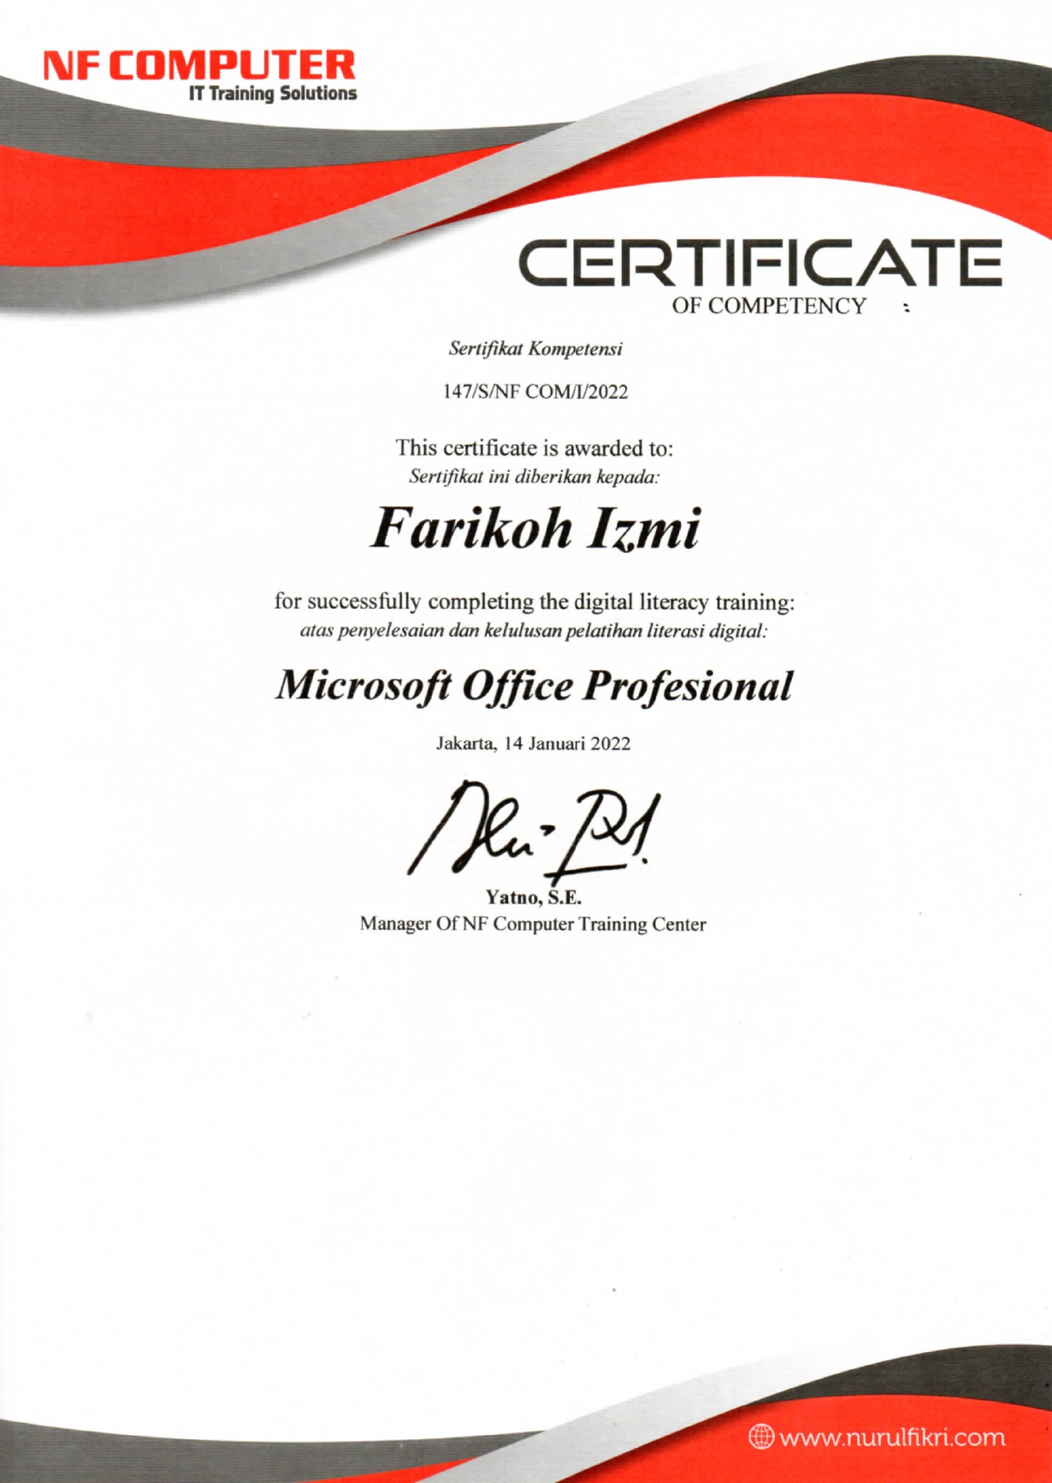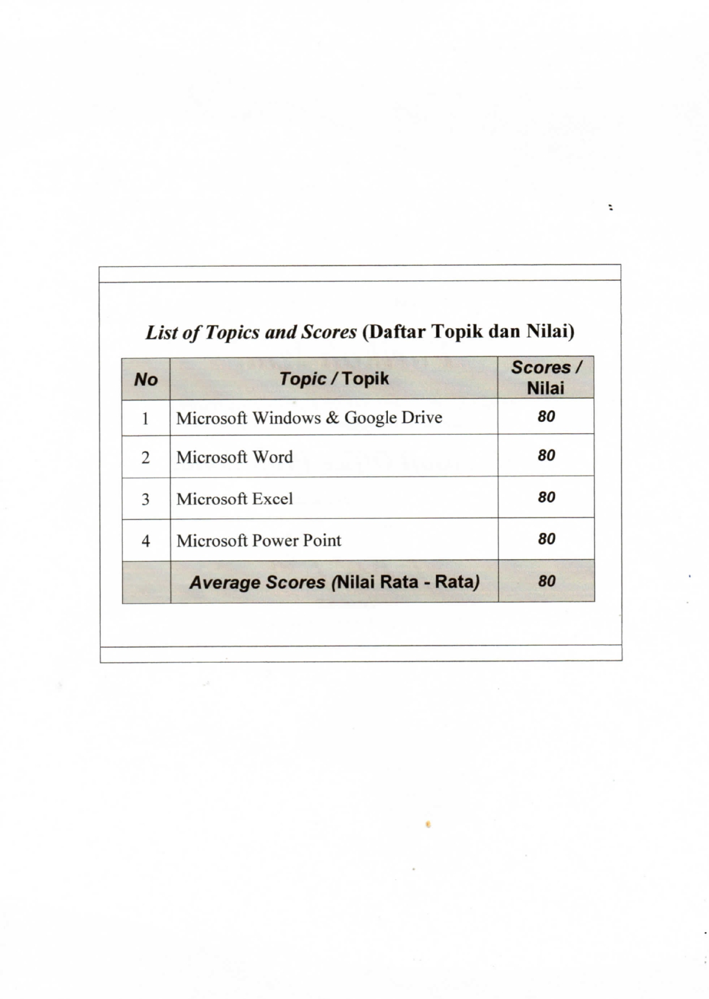

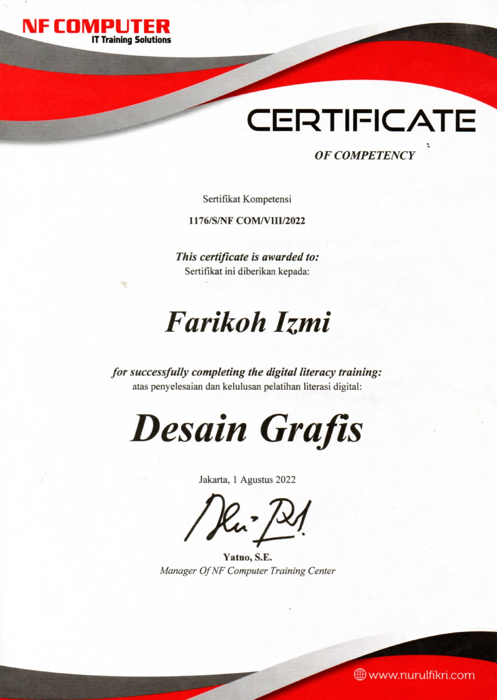

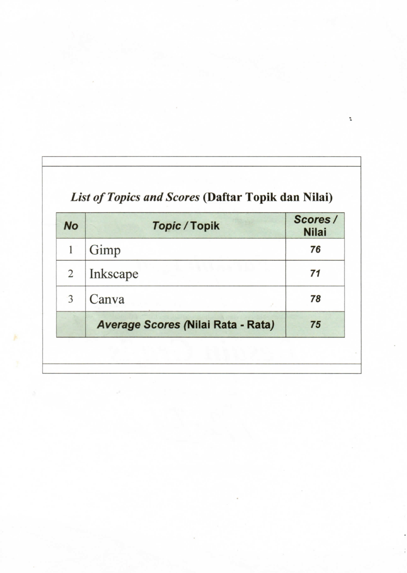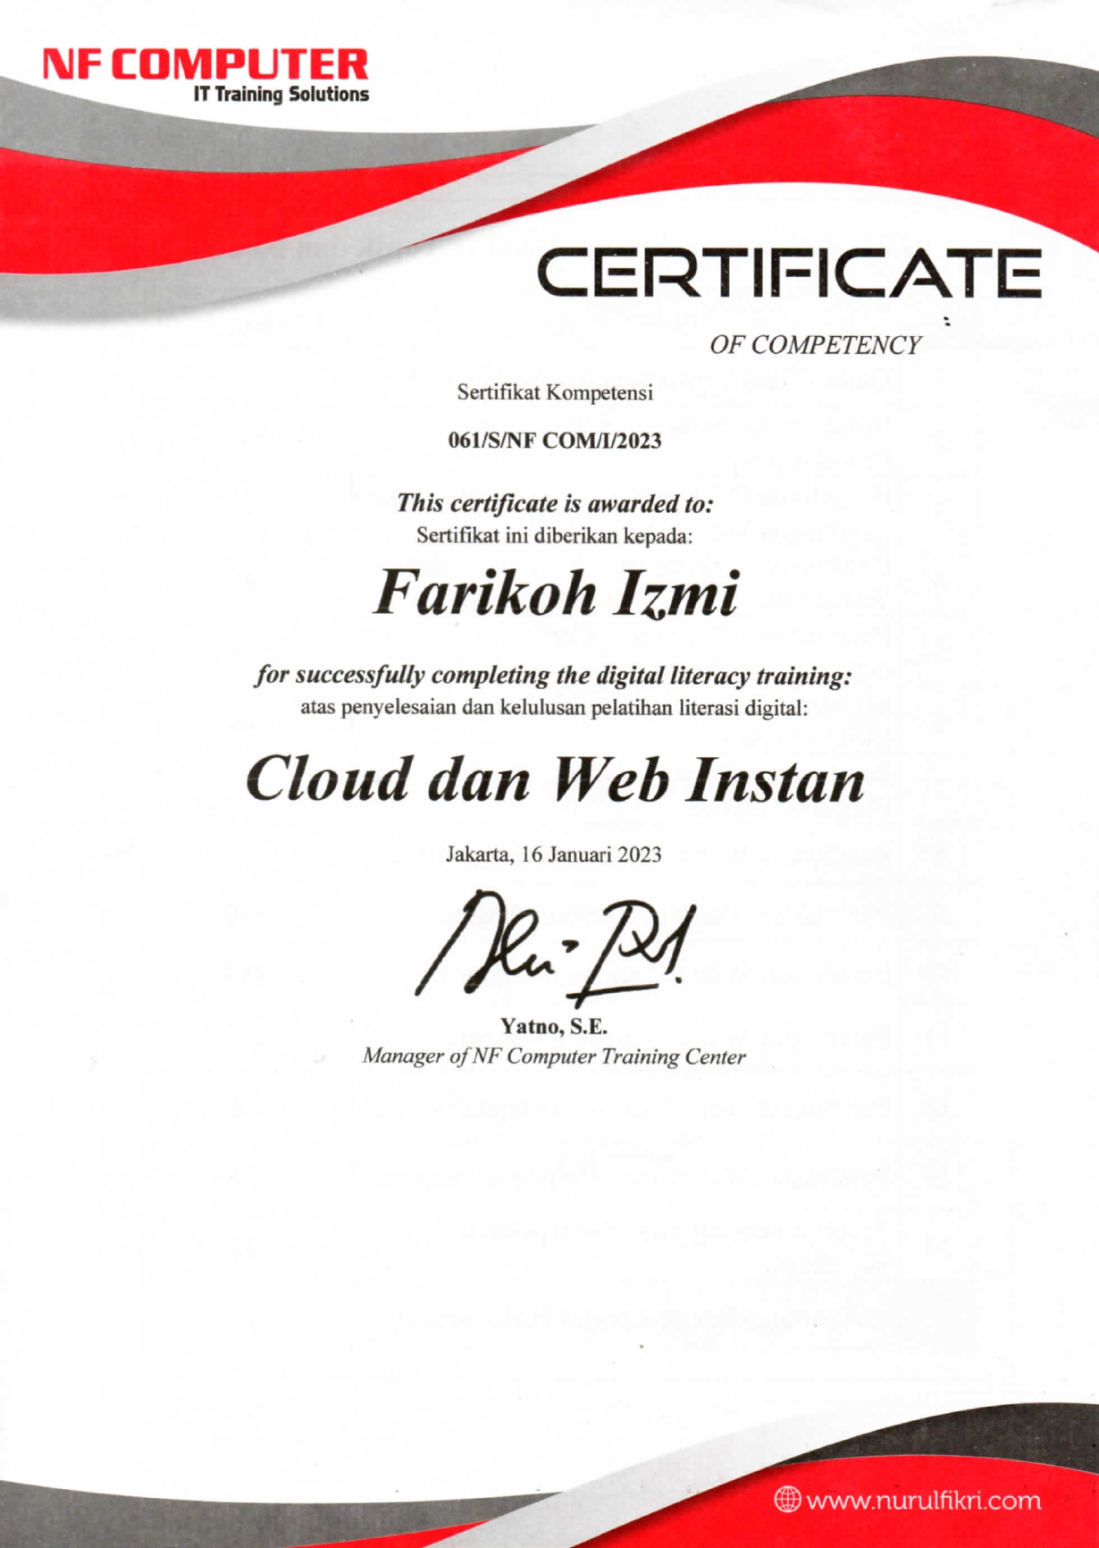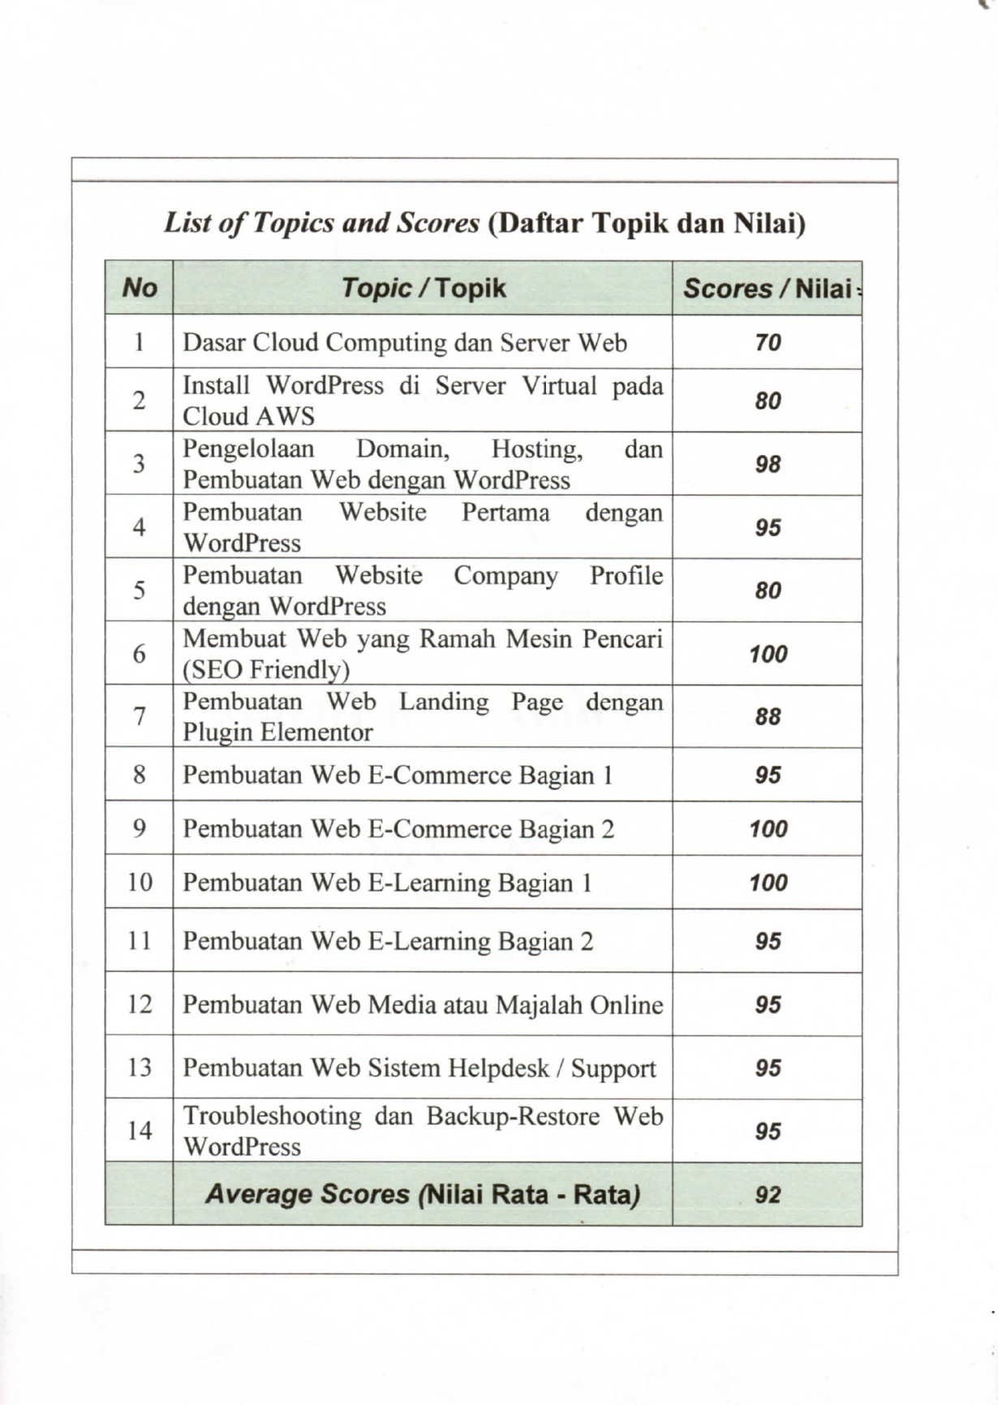

**Pengalaman Proyek**

1. Perancangan Aplikasi SelfCare

Mata Kuliah User Interface & User Experience - Sistem Informasi

<https://www.figma.com/proto/YKysJEsIpghvKs1EgDYAur/SelfCare?type=design&node-id=53-3362&t=ZDXwOywxZVlkRw1u-0&scaling=scale-down&page-id=0%3A1&starting-point-node-id=53%3A3362>

1. Perancangan Aplikasi We Payment

Pengantar Sistem Informasi - Sistem Informasi

<https://www.figma.com/proto/f9I3z3xY9cg90nkjxmjF3t/Untitled?type=design&node-id=1-3&t=EEmadi7KzucMLath-0&scaling=scale-down&page-id=0%3A1&starting-point-node-id=1%3A3>

1. Perancangan Aplikasi GoPaper

Mata Kuliah Rekayasa Perangkat Lunak - Sistem Informasi

<https://www.figma.com/proto/ZSlkKWHVe5zBIKDJeXg9D0/GreenGenie-App-Prototype-(Community)?type=design&node-id=49-250&t=40EpEJ2eY62aekBM-0&scaling=scale-down&page-id=0%3A1&starting-point-node-id=49%3A250&show-proto-sidebar=1>